**Recommendations for Big Mountain Ski Resort**

Big mountain ski resort recently installed a chair lift to help increase distribution of visitors across the mountain. With the new chair lift comes additional operating costs of about $1.5 million this season. For this reason, they decided to take a look at their pricing strategy to determine if their pricing strategy of charging a premium over the average price of resorts in its market segment was the best approach. In an effort to compensate for the additional operating cost of the chair lift the business had to determine if and by how much they would increase ticket prices or would they be forced to decrease features.

In response the business proposed 4 scenarios that they feel would validate the ticket cost. The scenarios include the permanent closure of up to 10 of the least used runs and keeping the price structure the same. Increase ticket prices to cover the additional operating cost or increase the price and add additional features. The additional features being evaluated are increasing the vertical drop by adding a run to a point 150 feet below the current longest trail including the installation of an additional chair lift to bring skiers back up. Increase the vertical drop as above but include 2 acres of snow making. Lastly increase the longest run by 0.2 mile to boast a run of 3.5 miles in length, which would require additional snow making coverage of 4 acres.

The model consisting of closing least used runs vs. change in ticket price to make up for the additional operating cost was analyzed and the analysis below (figure 1). The analysis shows that you

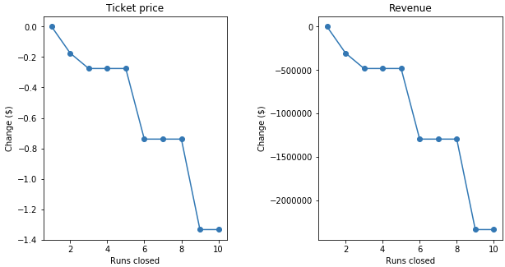

Figure 1 Analysis of closing runs vs revenue

can close up to 5 runs without significant change in ticket price with a relative drop of about $500,000 in revenue, any further drop of runs would result in much lower ticket prices and almost 3x loss of revenue.

The models for increasing price and adding features were analyzed and increasing the vertical drop by 150 feet would support a price increase of $8.67 and would increase the revenue to around $15 million. Looking at the same model but adding snow making over 2 acres would support a price increase of $10.59 per ticket and would generate and additional $3.5 million in revenue for a total of $18.5 million. The final model of increasing the longest run by 0.2 miles and guaranteeing snow coverage by the addition of 4 acres of snow making gave no difference for pricing tickets.

With the increase in revenue for scenario involving increasing the vertical drop by 150ft it would look like the logical choice for consideration as the scenarios for closing runs and adding to the longest run bring less (closing runs) or no change (increasing longest run) in revenue. Although the adding snow making to the increased vertical drop would increase revenue by $3.5 million dollars over the same option with no additional snow making this option also would require additional operating costs for snow making and is the extra cost for snow making validate the $2 price ticket increase. Further analysis should be performed with extra data such as cost for snow making, the optics of an $8.67 increase vs a $10.59 increase and the availability to move the people on the extra snow area.